CCI Nîmes

Travaux pratique 

Mise en pratique et réalisation d’une application client lourd



Réalisé et enseigné par

Jérôme Ferratier



Table des matières

Introduction

Utilisation du C# dans un environnement client a travers d’une IHM client lourd.

Pré requis

**Connaissance :**

C#

Base du .Net WPF 🡪 <https://learn.microsoft.com/fr-fr/dotnet/desktop/wpf/get-started/create-app-visual-studio?view=netdesktop-6.0>

***Outils :***

VS

C# – Initiation WPF

**Phase 1 :**

Etablir une structure comme ci-dessous.

Ecran partagé en 3 parties distinctes :

* Menu
  + Deux boutons vont devoir déclencher des actions.
  + Un champ doit récupérer le nom d’une ville.
* Informations principales
  + Température, vent, nom ville, date.
* Informations secondaires
  + Actualité de la ville. Météo de la semaine.

Rendu attendu :

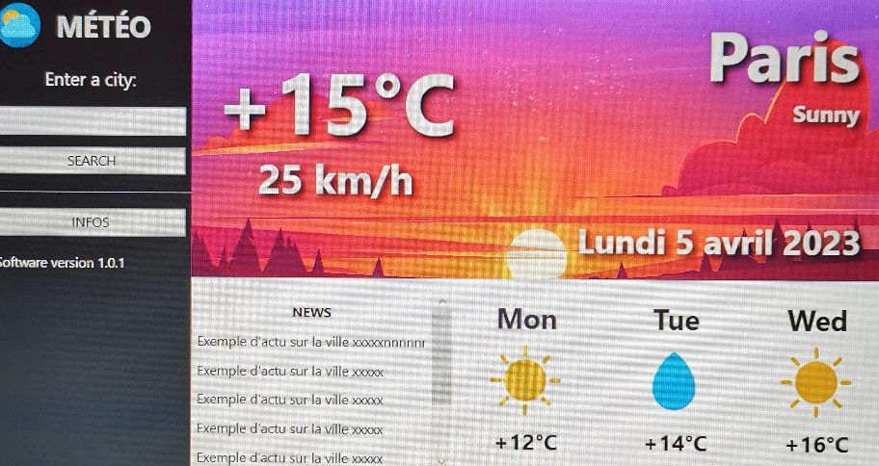

**Phase 2 :**

Inscrivez-vous sur le site <https://api.meteo-concept.com/>.

Ce site propose des web services fournissant des informations météorologiques à partir d’un code insee de ville.

Une fois inscrit, depuis le backend, votre code C# va pouvoir faire appel à ce type d’URL ( voir ci-dessous ) afin de récupérer la réponse de l’URL.

La réponse de l’URL sera au format JSON ( voir ci-dessous ).

https://api.meteo-concept.com/api/forecast/daily?token=f9fbf8ab431e676578b91c6651f7d4c4e9401f41783941523d93115fdff43024&insee=35238

{

"city": {

"insee": "35238",

"cp": 35000,

"name": "Rennes",

"latitude": 48.112,

"longitude": -1.6819,

"altitude": 38

},

"update": "2022-10-06T12:17:55+02:00",

"forecast": [

{

"insee": "35238",

"cp": 35000,

"latitude": 48.112,

"longitude": -1.6819,

"day": 0,

"datetime": "2022-10-06T02:00:00+0200",

"wind10m": 5,

"gust10m": 29,

"dirwind10m": 287,

"rr10": 0,

"rr1": 0,

"probarain": 0,

"weather": 1,

"tmin": 7,

"tmax": 19,

"sun_hours": 9,

"etp": 2,

"probafrost": 0,

"probafog": 20,

"probawind70": 0,

"probawind100": 0,

"gustx": 29

},

{

"insee": "35238",

"cp": 35000,

"latitude": 48.112,

"longitude": -1.6819,

"day": 1,

"datetime": "2022-10-07T02:00:00+0200",

"wind10m": 10,

"gust10m": 29,

"dirwind10m": 270,

"rr10": 0,

"rr1": 0,

"probarain": 10,

"weather": 3,

"tmin": 7,

"tmax": 19,

"sun_hours": 7,

"etp": 2,

"probafrost": 0,

"probafog": 40,

"probawind70": 0,

"probawind100": 0,

"gustx": 29

},

{

"insee": "35238",

"cp": 35000,

"latitude": 48.112,

"longitude": -1.6819,

"day": 2,

"datetime": "2022-10-08T02:00:00+0200",

"wind10m": 10,

"gust10m": 23,

"dirwind10m": 310,

"rr10": 0,

"rr1": 0,

"probarain": 10,

"weather": 1,

"tmin": 9,

"tmax": 19,

"sun_hours": 10,

"etp": 2,

"probafrost": 0,

"probafog": 20,

"probawind70": 0,

"probawind100": 0,

"gustx": 23

},

{

"insee": "35238",

"cp": 35000,

"latitude": 48.112,

"longitude": -1.6819,

"day": 3,

"datetime": "2022-10-09T02:00:00+0200",

"wind10m": 20,

"gust10m": 34,

"dirwind10m": 209,

"rr10": 0.5,

"rr1": 1,

"probarain": 50,

"weather": 3,

"tmin": 8,

"tmax": 21,

"sun_hours": 3,

"etp": 3,

"probafrost": 0,

"probafog": 0,

"probawind70": 0,

"probawind100": 0,

"gustx": 43

},

{

"insee": "35238",

"cp": 35000,

"latitude": 48.112,

"longitude": -1.6819,

"day": 4,

"datetime": "2022-10-10T02:00:00+0200",

"wind10m": 10,

"gust10m": 24,

"dirwind10m": 204,

"rr10": 2.4,

"rr1": 2.4,

"probarain": 60,

"weather": 40,

"tmin": 12,

"tmax": 18,

"sun_hours": 3,

"etp": 2,

"probafrost": 0,

"probafog": 0,

"probawind70": 0,

"probawind100": 0,

"gustx": 34

},

{

"insee": "35238",

"cp": 35000,

"latitude": 48.112,

"longitude": -1.6819,

"day": 5,

"datetime": "2022-10-11T02:00:00+0200",

"wind10m": 10,

"gust10m": 21,

"dirwind10m": 63,

"rr10": 0.4,

"rr1": 0.4,

"probarain": 60,

"weather": 3,

"tmin": 11,

"tmax": 18,

"sun_hours": 4,

"etp": 2,

"probafrost": 0,

"probafog": 20,

"probawind70": 0,

"probawind100": 0,

"gustx": 31

},

{

"insee": "35238",

"cp": 35000,

"latitude": 48.112,

"longitude": -1.6819,

"day": 6,

"datetime": "2022-10-12T02:00:00+0200",

"wind10m": 15,

"gust10m": 27,

"dirwind10m": 240,

"rr10": 0.2,

"rr1": 0.2,

"probarain": 60,

"weather": 3,

"tmin": 10,

"tmax": 18,

"sun_hours": 6,

"etp": 2,

"probafrost": 0,

"probafog": 0,

"probawind70": 0,

"probawind100": 0,

"gustx": 35

},

{

"insee": "35238",

"cp": 35000,

"latitude": 48.112,

"longitude": -1.6819,

"day": 7,

"datetime": "2022-10-13T02:00:00+0200",

"wind10m": 15,

"gust10m": 28,

"dirwind10m": 247,

"rr10": 5.9,

"rr1": 7.9,

"probarain": 60,

"weather": 40,

"tmin": 11,

"tmax": 16,

"sun_hours": 4,

"etp": 1,

"probafrost": 0,

"probafog": 0,

"probawind70": 10,

"probawind100": 0,

"gustx": 42

},

{

"insee": "35238",

"cp": 35000,

"latitude": 48.112,

"longitude": -1.6819,

"day": 8,

"datetime": "2022-10-14T02:00:00+0200",

"wind10m": 20,

"gust10m": 33,

"dirwind10m": 257,

"rr10": 5.4,

"rr1": 21,

"probarain": 60,

"weather": 41,

"tmin": 10,

"tmax": 15,

"sun_hours": 4,

"etp": 2,

"probafrost": 0,

"probafog": 0,

"probawind70": 0,

"probawind100": 0,

"gustx": 48

},

{

"insee": "35238",

"cp": 35000,

"latitude": 48.112,

"longitude": -1.6819,

"day": 9,

"datetime": "2022-10-15T02:00:00+0200",

"wind10m": 20,

"gust10m": 30,

"dirwind10m": 246,

"rr10": 7.2,

"rr1": 21,

"probarain": 60,

"weather": 41,

"tmin": 9,

"tmax": 14,

"sun_hours": 5,

"etp": 2,

"probafrost": 0,

"probafog": 0,

"probawind70": 0,

"probawind100": 0,

"gustx": 45

},

{

"insee": "35238",

"cp": 35000,

"latitude": 48.112,

"longitude": -1.6819,

"day": 10,

"datetime": "2022-10-16T02:00:00+0200",

"wind10m": 15,

"gust10m": 26,

"dirwind10m": 277,

"rr10": 8,

"rr1": 22,

"probarain": 60,

"weather": 41,

"tmin": 8,

"tmax": 14,

"sun_hours": 6,

"etp": 1,

"probafrost": 0,

"probafog": 0,

"probawind70": 0,

"probawind100": 0,

"gustx": 39

},

{

"insee": "35238",

"cp": 35000,

"latitude": 48.112,

"longitude": -1.6819,

"day": 11,

"datetime": "2022-10-17T02:00:00+0200",

"wind10m": 15,

"gust10m": 23,

"dirwind10m": 286,

"rr10": 5.1,

"rr1": 12.9,

"probarain": 60,

"weather": 40,

"tmin": 8,

"tmax": 14,

"sun_hours": 6,

"etp": 1,

"probafrost": 0,

"probafog": 0,

"probawind70": 0,

"probawind100": 0,

"gustx": 36

},

{

"insee": "35238",

"cp": 35000,

"latitude": 48.112,

"longitude": -1.6819,

"day": 12,

"datetime": "2022-10-18T02:00:00+0200",

"wind10m": 10,

"gust10m": 21,

"dirwind10m": 276,

"rr10": 2.2,

"rr1": 14.4,

"probarain": 60,

"weather": 41,

"tmin": 8,

"tmax": 14,

"sun_hours": 5,

"etp": 1,

"probafrost": 0,

"probafog": 0,

"probawind70": 0,

"probawind100": 0,

"gustx": 36

},

{

"insee": "35238",

"cp": 35000,

"latitude": 48.112,

"longitude": -1.6819,

"day": 13,

"datetime": "2022-10-19T02:00:00+0200",

"wind10m": 10,

"gust10m": 20,

"dirwind10m": 258,

"rr10": 5.1,

"rr1": 8.9,

"probarain": 60,

"weather": 40,

"tmin": 8,

"tmax": 14,

"sun_hours": 4,

"etp": 1,

"probafrost": 0,

"probafog": 20,

"probawind70": 0,

"probawind100": 0,

"gustx": 30

}

]

}